South Yorkshire
Local Nature Partnership

Date: 15th June 2017

Dear Paula

Re: Barnsley’s Local Plan

At our recent Local Nature Partnership Board (LNP) meeting, Pete Wall reported on a meeting of 20th April 2017 with you and your colleagues to review a number of policies in the Draft Barnsley Local Plan.

As a result, I am writing at the Board’s request to commend you on your approach to engaging with us on your Local Plan development under the ‘duty to co-operate’ with the LNP.

We particularly welcome Barnsley’s approach to working with us as well as your specific policies on green infrastructure and protecting and promoting improvements to the natural environment and environmental corridors. The latest version of the Local Plan demonstrates that Barnsley Council officers have taken on board many of the comments received from environmental organisations working in the borough and have translated these into positive policy statements that should benefit both wildlife and people in the future. Obviously we are also keen to see how these policies are translated in to decisions and the delivery of development proposals in the future and we would look forward to further assisting you in that process.

Yours sincerely
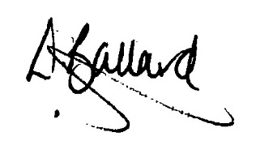

Liz Ballard
Chair
South Yorkshire Local Nature Partnership Board

