South Yorkshire
Local Nature Partnership

Date: 1st June 2018

Dear Dan Jarvis MP
Congratulations on your election as the first Sheffield City Region Mayor.

I am writing to you in my capacity as the elected Chair of the South Yorkshire Local Nature Partnership Board (LNP). You may not be aware but the role of LNPs was set out following the Government’s publication of the Natural Environment White Paper in 2012. Defra called for Local Nature Partnerships to be established across England to “bring a diverse range of businesses and organisations together to create a vision and plan of action of how the natural environment can be taken into account in decision-making to raise awareness about the services and benefits of a healthy natural environment.” LNPs were seen as the ‘green mirror’ to the LEP’s.

The South Yorkshire LNP was established in 2012. Sheffield & Rotherham Wildlife Trust currently provides the secretariat support the Board, which is comprised of representatives from the Defra agencies, voluntary sector (including ourselves, Yorkshire Wildlife Trust, CPRE), Sheffield Hallam University, private sector/consultants and the 4 local authorities.

We have recently develop and refreshed our vision as follows:
"South Yorkshire's natural environment is valued, enhanced, celebrated and enjoyed by everyone and is recognised for the essential contribution it makes to the local economy and peoples' quality of life."
And developed a short supporting strategy given our limited resources.

The SYLNP Board are interested to hear about your ideas and ambitions for the natural environment of the City Region for the future. We recognise that you have limited powers and resources but strongly believe that the region would greatly benefit across social, economic and environmental aims if there was a champion for the natural environment such as yourself. Issues such as developing and sustaining a network for nature, the threats and opportunities presented by HS2, the duty to consult with LNPs on local plans, engagement with the Local Enterprise Partnership, the taking forward of the Government’s 25yr Environment Plan, including the Northern Forest and proposals to plan 1million trees in urban areas, are all of interest to the SYLNP Board. And of course promoting the fantastic natural assets the region already has.

Are these areas of interest to you in your capacity as Mayor? Would you be interested in a discussion about these and other environmental issues relevant to the City Region?
We would also like to hear about any plans you may have for ‘place-making/shaping’ in your capacity as Mayor. Other Regions, such as Manchester and Birmingham have established Nature/Environment Partnerships to focus on this area of work and bring together different sectors and organisations.
If you would be interested in discussing any of the above further, then please let me know a convenient date to do so or you would be very welcome to attend a future LNP Board meeting.
Yours sincerely
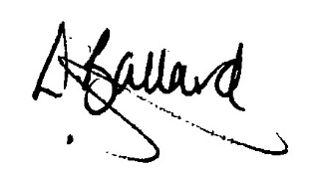
Liz Ballard
Chair, South Yorkshire Local Nature Partnership

Yours sincerely
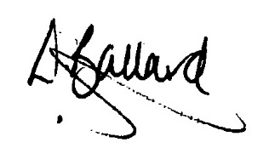

Liz Ballard
Chair
South Yorkshire Local Nature Partnership Board

