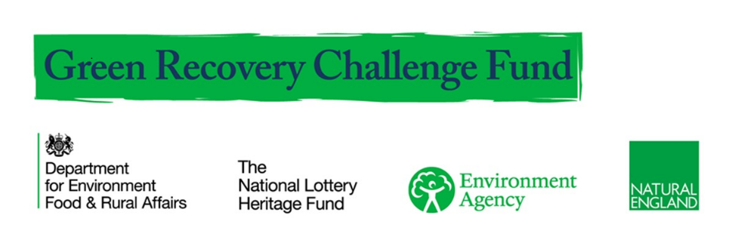
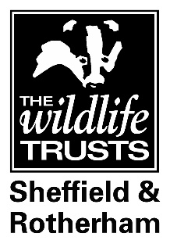

This position is kindly funded by The Green Recovery Challenge Fund. The Green Recovery Challenge Fund is funded by Defra and is being delivered by The National Lottery Heritage Fund in partnership with Natural England and the Environment Agency.

JOB DESCRIPTION

JOB TITLE: Nature Recovery Programme Manager (NRPM21)

Reporting to: Chief Executive, Sheffield & Rotherham Wildlife Trust

Responsible for: Admin Officer (part-time)

Salary: £29,411 p/a, pro rata 0.8 FTE (4days/week)
+ 9% employee pension contribution entitlement*
Fixed Term – GRCF projects must be completed by 31st March 2022

OVERALL PURPOSE OF JOB
Oversee and manage the delivery of the South Yorkshire Nature Networks project, helping to make a step change for nature’s recovery. Support the Trust working with the South Yorkshire Local Nature Partnership (SYLNP) in the development of pilot Local Nature Recovery Strategies in South Yorkshire.

Work with the Team, Trust staff and partners across Sheffield & Rotherham to oversee onsite delivery and community engagement. Ensure that the project meets or exceeds Green Recovery Challenge Fund requirements and the project plan, budget and reporting deadlines.

MAIN RESPONSIBILITIES:
Work with the Trust and SY LNP to test and pilot approaches to developing Local Nature Recovery Strategies in South Yorkshire, drawing on best practice, current data, mapping and information as well as other Local Nature Recovery Strategy national pilots.
Recruit and line manage the Admin Officer to undertake the day to day financial and administration tasks to support the project.
Oversee the delivery of four local site projects and ensure their learning and feedback informs the development of the Local Nature Recovery Strategy process.
Manage all aspects of the Project, including liaising with the SY LNP Woodland Creation Officer in relation to the Trainee placements, to ensure all strands of work are delivered on time and to budget.
Promote and publicise the Project through a variety of media channels including social media with support from the Trust’s marketing team.
Develop excellent relationships with partners to ensure the Project draws on the skills, experience and learning offered across South Yorkshire and beyond.
Manage the project in accordance with the GRCF Project Plan, ensuring key milestones are met and all Claims are submitted accurately and on time, with additional documentation and evidence provided as required.
Manage the budget and ensure services are procured appropriately so that all funder requirement and conditions are met.
Any other related duties and responsibilities as may arise.

General Duties
Work to and promote the Trust’s Charitable Objectives, Strategy, policies and procedures, including the Trust’s culture statement
Where appropriate, promote membership of the Trust
Present a professional image of the Trust at all times

ABOUT SOUTH YORKSHIRE NATURE NETWORKS
This project will help achieve a step change in nature recovery in South Yorkshire.

Working at a strategic level with the South Yorkshire Local Nature Partnership (SYLNP), this role will lead the initial development of Local Nature Recovery Strategies in the region.

Using Habitat Opportunity maps already commissioned by the SYLNP and the Sheffield City Region Mayoral Combined Authority, the post-holder will work with a range of partners from across South Yorkshire to develop nature recovery networks as well as identify initial targets & plans for investment in nature’s recovery.

The post-holder will also work with a range of onsite projects and partners in Sheffield and Rotherham, to ensure that, right from the start, development of the Local Nature Recovery Strategies is embedded in on-the-ground activities and community engagement. Planned activities include: woodland and wetland habitat creation, expansion and enhancement; nature based solutions - tree planting and leaky dam creation, and opportunities and infrastructure to better connect diverse urban communities with nature on their doorstep.

Sheffield and Rotherham Wildlife Trust is the secretariat for the South Yorkshire Local Nature Partnership. For more information about SYLNP please visit: https://www.wildsheffield.com/sylnp/

ABOUT SHEFFIELD AND ROTHERHAM WILDLIFE TRUST
The Trust applied for the Green Recovery Challenge Fund grant and will employ the post-holder.

Sheffield and Rotherham Wildlife Trust is one of 46 Wildlife Trusts working to make the United Kingdom a better place for people and wildlife. We are supported by nearly 6,000 members and hundreds of local volunteers.

We are part of the local community, working to protect and enhance the environment of Sheffield and Rotherham for the benefit of people and wildlife. The Trust manages 15 Nature Reserves including Greno Woods, Wyming Brook, Blacka Moor, Sunnybank and Centenary Riverside and recent projects include the delivery of natural flood risk management schemes on the Rother and recording the return of the otter along the River Don. The Trust delivers a great programme of activities throughout the year to inspire people of all ages to learn about nature and enjoy being outdoors. We also take action for wildlife and green spaces under threat, including successfully campaigning to save an ancient woodland and local wildlife site, Smithy Wood, from being turned into a motorway service station. For more information about our work please visit www.wildsheffield.com or phone 0114 263 4335 or email: mail@wildsheffield.com

With more than 800,000 members, the Wildlife Trusts are the largest UK voluntary organisation dedicated to conserving the full range of the UK's habitats and species. Collectively we manage over 2,300 nature reserves covering more than 90,000 hectares.

DETAILS OF EMPLOYMENT

Salary: £29,411.41/pa, pro rata 0.8 FTE (Programme Manager Grade)

Pension: Entry to the Trust's pension scheme is available immediately, with no employer contribution made. All staff who earn over £192 per week (£833 per month) are over 22 and under pensionable age, are automatically enrolled on the SRWT pension scheme following a 3-month postponement period. SRWT will contribute 3% and the employee 5%.
After 6 month’s service and completion of a successful probationary period the employee will be entitled to a 9% employer contribution which need not be matched.
Anyone who does not meet eligibility criteria will have the opportunity to join the scheme should they wish, although they will not qualify for SRWT contributions.

Working Hours: 4day/week (0.8 FTE). The post may involve some evening work for which time off in lieu can be taken. Flexi-time is available as part of our Covid19 working arrangements.

Location: The post will be based at Victoria Hall, but is likely to require visits to partner sites. Homeworking is also essential (equipment will be provided by the Trust) during Covid19.

Probationary Period: All new employees are required to undertake a period of probation for 6 months, in which they will be expected to establish their suitability for the post.

Annual Leave: 20 days a year pro rata plus bank holidays pro rata and 3 additional days to cover the period between Christmas and New Year when the office is closed.

Length of Contract: For the duration of the South Yorkshire Nature Networks project (December 2020 – March 2022).

Transport provision: Trust staff are required to use public transport wherever practical. (Please read SRWT environmental policy for further guidance). However the postholder will have use of a pool of Trust vehicles when needed.

Equal Opportunities: Sheffield and Rotherham Wildlife Trust is striving to be an equal opportunities employer and selection of applicants is based on merit. Please refer to the enclosed policy document for further details.

DBS check: Not required for this post

PERSON SPECIFICATION

Area A EXPERIENCE

- At least 3 years’ relevant experience of developing landscape scale strategies, developing and delivering landscape scale conservation, habitat and/or species plans, with strategic partners and communities
- Experience of, and a commitment to nature’s recovery and the use of data, mapping, ground-truthing and community involvement to inform and improve nature conservation advocacy and delivery
- Experience of developing and managing partnership projects
- Experience of community engagement in nature’s recovery
- Experience of overseeing project management including budgets and funding, ideally Heritage Lottery Funding or similar

Desirable
Experience working with or in a Local Authority planning or ecology team.

Area B KNOWLEDGE/QUALIFICATIONS

- Degree/equivalent qualification in ecology, conservation or related discipline.
- Good knowledge of proposed changes to environmental legislation and an understanding of how this may translate in practice.
- Good knowledge of ecological data and mapping processes, monitoring frameworks and networks
- Good understanding of how to work with a wide range of partners: public and private and approaches need to develop new systems and ways of working.
- Good understanding of priority habitats and species, especially in relation to Sheffield and Rotherham
- Full driving licence or appropriate means to travel for this job.

Desirable
- Relevant postgraduate qualification eg in management or ecology

Area C SKILLS

- Able to work with modelling, datasets and GIS layers in order to inform and guide strategic decision making
- Able to use IT effectively, including QGIS, as well as internet, email, word-processing and spreadsheets.
- Able organise and prioritise your own workload effectively
- Able to direct others, identify critical pathways and priorities in order to keep projects on track and to task
- Excellent communication and interpersonal skills to promote the project

Area D PERSONAL QUALITIES

- Can think strategically and deliver locally
- Highly motivated and enthusiastic with an ability to enthuse and motivate others.
- Can build good working relationships with a wide variety of individuals and organisations.

